ArgoCD Sync Policy Labs - Hands-on UI Testing
Lab 1: Auto-Sync and Self-Heal Testing
Objective
Test ENABLE AUTO-SYNC and SELF HEAL options to understand automated synchronization and drift correction.
Prerequisites
- ArgoCD installed and accessible
- GitHub/GitLab repository with sample application
Setup Steps
Fork the repo to your account
https://github.com/amitopenwriteup/argoappsynclab.git
Map as source in your project

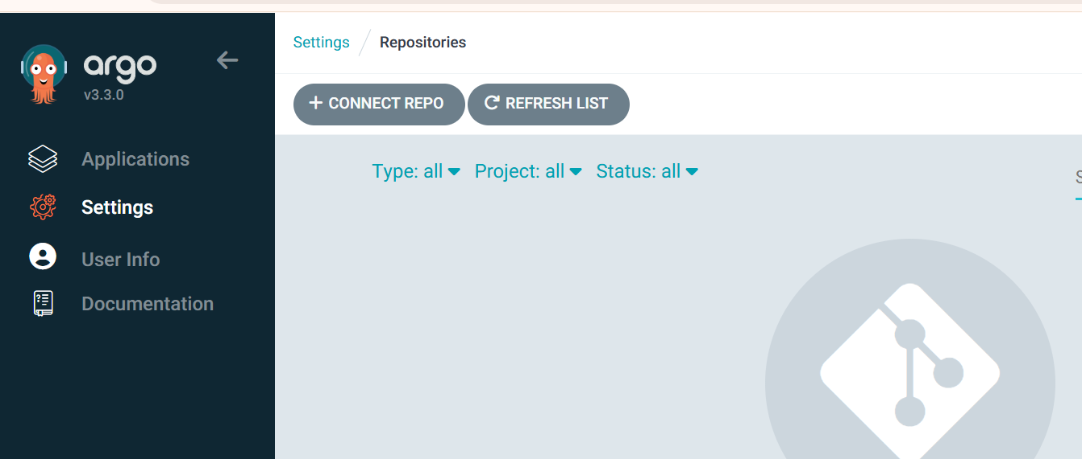
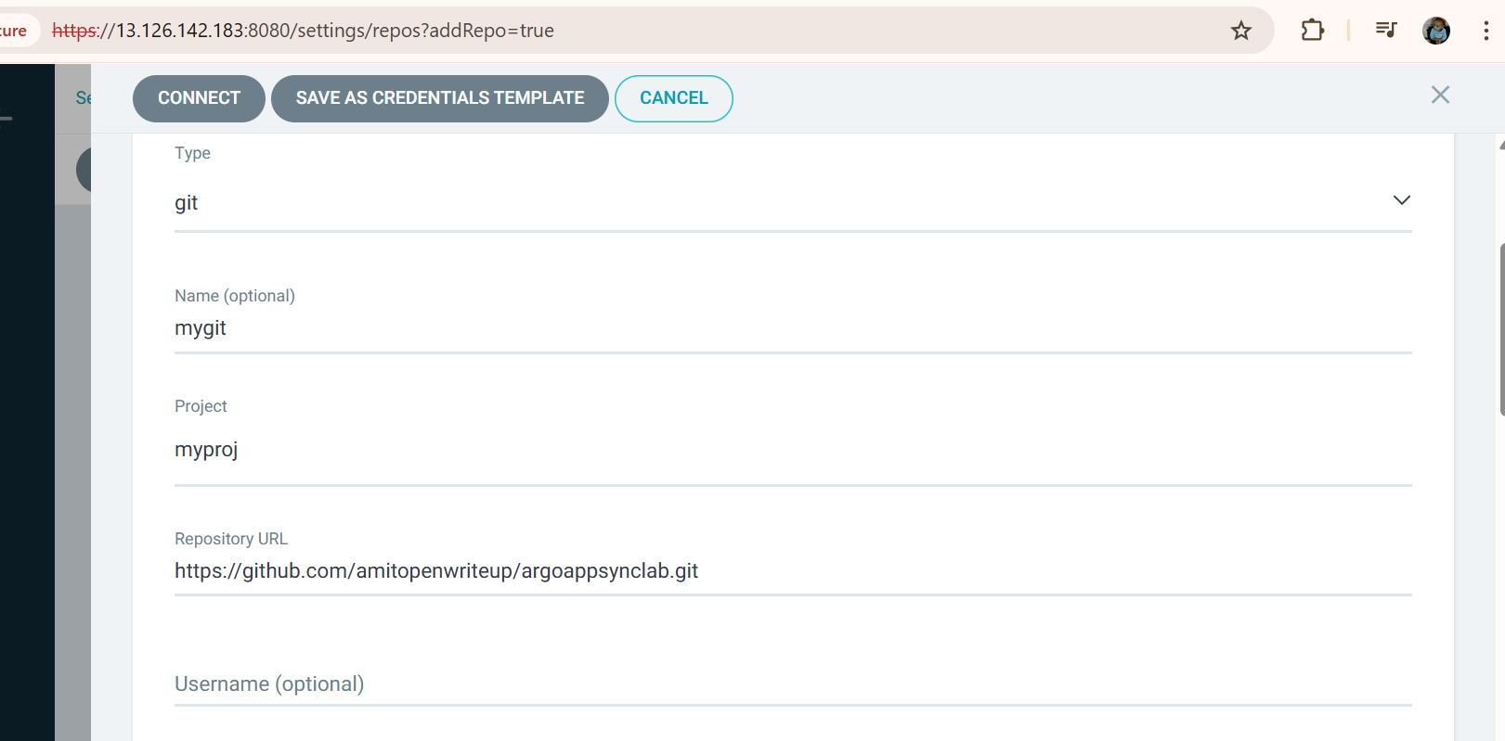

2. Create Application in ArgoCD UI
Navigate to ArgoCD UI:
- Click "+ NEW APP" button
- Fill in the following:
GENERAL:
- Application Name: lab1-autosync
- Project: myproj(Provide your project name)
- Sync Policy: Automatic
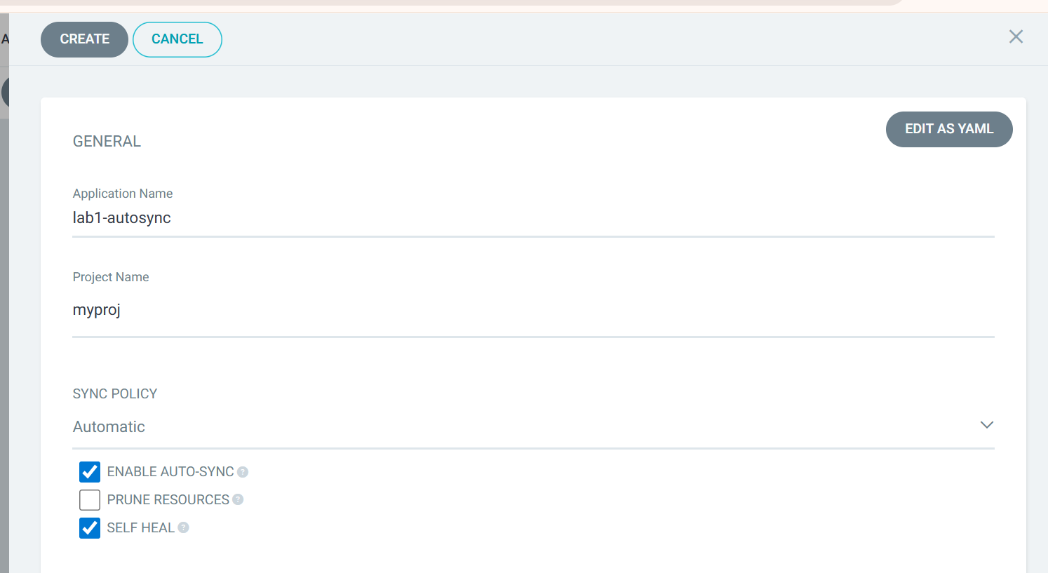
SOURCE:
- Repository URL: <YOUR_REPO_URL>
- Revision: HEAD
- Path: lab1-autosync
DESTINATION:
- Cluster URL: https://kubernetes.default.svc
- Namespace: lab1
SYNC POLICY Section:
- ✅ ENABLE AUTO-SYNC (check this box)
- ⬜ PRUNE RESOURCES (leave unchecked for now)
- ✅ SELF HEAL (check this box)
SYNC OPTIONS Section:
- ✅ AUTO-CREATE NAMESPACE (check this box)
- Click CREATE
3. Test Scenarios
Test 1: Auto-Sync on Git Changes
# Modify the deployment
Go to github.com repo and path lab1-autosync
Edit the deployment.yamlreplicas: 2 to replicas: 3

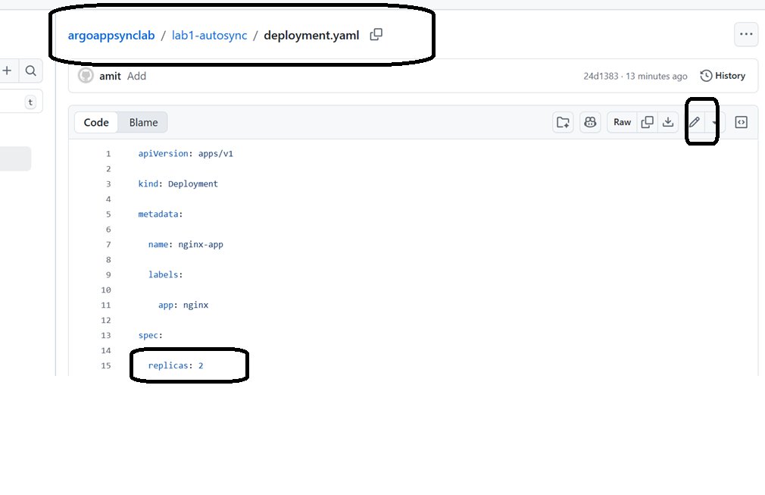
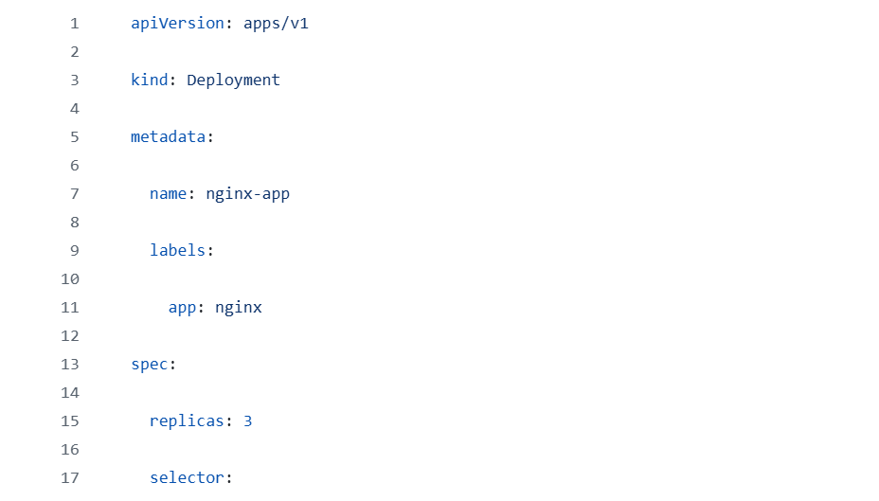
# Watch in ArgoCD UI
# The app should automatically sync within 3 minutes (default polling interval)
# You'll see the sync status change and replicas update
Observe in UI:
- Application will show "Syncing" status
- Progress bar will appear
- Once complete, status changes to "Synced" and "Healthy"

NOTE: IF require press Refresh
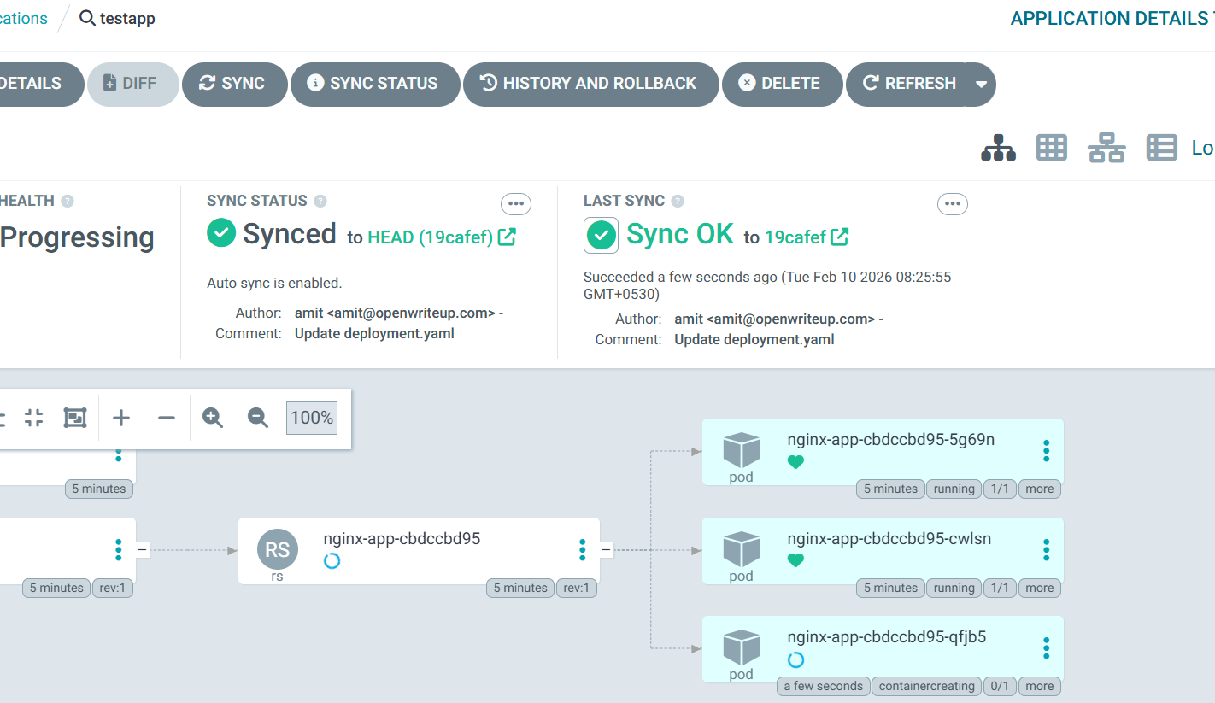

Test 2: Self-Heal - Manual Changes
# Manually modify the deployment in cluster
kubectl scale deployment nginx-app -n lab1 --replicas=5

# Watch what happens
kubectl get deployment nginx-app -n lab1 -w
Observe in UI:
- Application will show "OutOfSync" briefly
- Self-heal will trigger automatically
- Deployment will revert back to 3 replicas (as defined in Git)
- Status returns to "Synced"
Cleanup
# In ArgoCD UI
# Click on lab1-autosync → Click "DELETE" → Confirm

Lab 2: Prune Resources and Deletion Finalizer
Objective
Test PRUNE RESOURCES and SET DELETION FINALIZER to understand resource cleanup behavior.
Setup Steps
1. Create Application Repository
Same repo: lab2-prune
1. Create Application in ArgoCD UI
- Click "+ NEW APP"
GENERAL:
- Application Name: lab2-prune
- Project: myproj
- Sync Policy: Automatic
SOURCE:
- Repository URL: <YOUR_REPO_URL>
- Revision: HEAD
- Path: lab2-prune
DESTINATION:
- Cluster URL: https://kubernetes.default.svc
- Namespace: lab2
SYNC POLICY:
- ✅ ENABLE AUTO-SYNC
- ✅ PRUNE RESOURCES (check this box)
- ✅ SELF HEAL
- ✅ SET DELETION FINALIZER (check this box)
SYNC OPTIONS:
- ✅ AUTO-CREATE NAMESPACE
- Click CREATE
- Click SYNC to deploy
3. Test Scenarios
Test 1: Verify All Resources Created
kubectl get all,cm,secret -n lab2

# You should see:
# - Deployment: web-app
# - Service: web-service
# - ConfigMap: app-config
# - Secret: app-secret
# - Pods running
Test 2: Test Prune Resources
# Make sure you have configured ssh authentication for your github account
sudo su
ssh-keygen -t rsa
#No need to provide keyname, just press enater
#No need to provide the passhrase, press enter two time
cat /root/.ssh/id_rsa.pub
#copy the key
#go to github

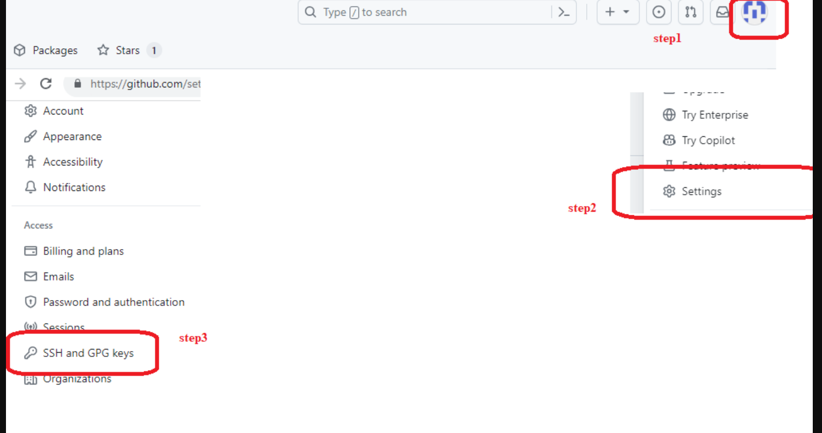

Copy the ssh url

#paste the key

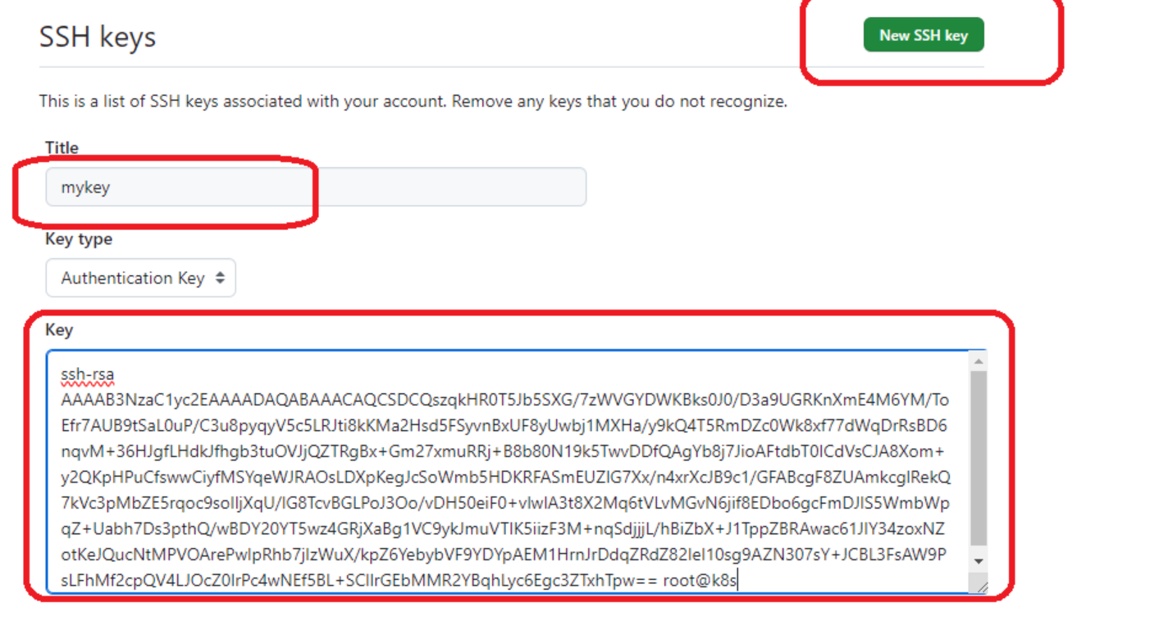

#Copy the ssh url
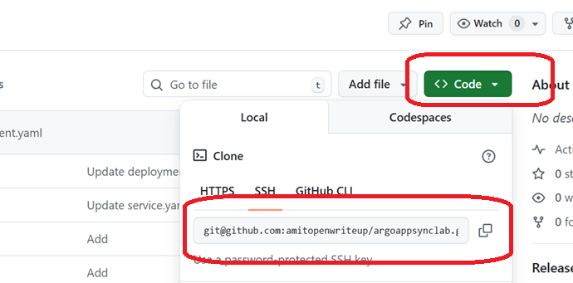

#Replace it with your url

git clone <your ssh url>
cd argoappsynclab/
cd lab2-prune
# Remove the secret from Git
#Delete the secret.yaml,from git repo
rm secret.yaml
git add .
git commit -m "remove secret"
git push origin main

# Watch in real-time
kubectl get secret app-secret -n lab2 -w
Observe in UI:
- ArgoCD will detect the change
- Auto-sync will trigger
- Secret will be automatically deleted (pruned) from cluster
- Referesh page if require

- Application remains "Synced"
Test 3: Add Resource Back
# Restore the secret
git revert HEAD
#Press ctrl + X and enter
git push

# Watch it get recreated
kubectl get secret -n lab2 -w
Test 4: Test Deletion Finalizer
# Try to delete the application from UI
# Click on lab2-prune → Click "DELETE"
Observe in UI:
- Check the "Foregroun" option
- Because we set deletion finalizer, you'll see cleanup happening
- The finalizer ensures proper cleanup

Lab 3: Sync Options Testing
Objective
Test SKIP SCHEMA VALIDATION, PRUNE LAST, RESPECT IGNORE DIFFERENCES, and REPLACE options.
Setup Steps
1. Create Application Repository
2. Create Application in ArgoCD UI - Configuration 1
First, test without options:
- Click "+ NEW APP"
GENERAL:
- Application Name: lab3-sync-options
- Project: myproj
- Sync Policy: Manual (we'll sync manually to see effects)
SOURCE:
- Repository URL: <YOUR_REPO_URL>
- Revision: HEAD
- Path: lab3-sync-options
DESTINATION:
- Cluster URL: https://kubernetes.default.svc
- Namespace: lab3
SYNC POLICY:
- ⬜ All options unchecked initially
SYNC OPTIONS:
- ⬜ SKIP SCHEMA VALIDATION (unchecked)
- ⬜ PRUNE LAST (unchecked)
- ⬜ RESPECT IGNORE DIFFERENCES (unchecked)
- ✅ AUTO-CREATE NAMESPACE
- ⬜ APPLY OUT OF SYNC ONLY
- ⬜ SERVER-SIDE APPLY
- ⬜ REPLACE
- Click CREATE
- Click SYNC → SYNCHRONIZE
3. Test Scenarios
Test 1: SKIP SCHEMA VALIDATION
cd lab3-sync-options

# Create a resource with intentional schema issue (wrong field name)
cat > bad-deployment.yaml << 'EOF'
apiVersion: apps/v1
kind: Deployment
metadata:
name: bad-app
spec:
replicas: 1
selector:
matchLabels:
app: bad
template:
metadata:
labels:
app: bad
spec:
containers:
- name: app
image: nginx:1.21
wrongField: "this will fail validation"
EOF

git add bad-deployment.yaml
git commit -m "Add deployment with validation error"
git push
Observe in UI:
- Click REFRESH in ArgoCD UI
- Try to SYNC
- You'll see a validation error
- Now go to app settings:
  - Click APP DETAILS → EDIT
  - Find SYNC OPTIONS
  - ✅ Check SKIP SCHEMA VALIDATION
  - Click SAVE
- Try SYNC again
- The validation will be skipped (though it may still fail at apply)
Test 2: PRUNE LAST
# Remove the bad deployment and create proper multi-resource setup
git rm bad-deployment.yaml
git commit -m "Remove bad deployment"
git push

# Add a resource that depends on configmap
cat > deployment-with-dependency.yaml << 'EOF'
apiVersion: apps/v1
kind: Deployment
metadata:
name: app-with-config
spec:
replicas: 1
selector:
matchLabels:
app: config-user
template:
metadata:
labels:
app: config-user
spec:
containers:
- name: app
image: nginx:1.21
volumeMounts:
- name: config
mountPath: /etc/config
volumes:
- name: config
configMap:
name: demo-config
EOF

git add deployment-with-dependency.yaml
git commit -m "Add deployment with configmap dependency"
git push

# Now remove the configmap
git rm configmap.yaml
git commit -m "Remove configmap (will cause issues)"
git push
Observe in UI:
- Enable PRUNE RESOURCES in sync policy
- Enable PRUNE LAST in sync options
- Click SYNC
- With PRUNE LAST, dependent resources are deleted before the configmap
- This prevents errors from missing dependencies
Test 3: RESPECT IGNORE DIFFERENCES
# First, configure ignore differences
# In ArgoCD UI:
# 1. Click app → APP DETAILS → EDIT
# 2. Scroll to bottom, add IGNORE DIFFERENCES section
Add this configuration in UI (use YAML mode):
ignoreDifferences:
- group: apps
kind: Deployment
jsonPointers:
- /spec/replicas
# Now manually scale the deployment
kubectl scale deployment demo-app -n lab3 --replicas=5

# Check UI - app should show OutOfSync
# Now enable RESPECT IGNORE DIFFERENCES in sync options
# Click SYNC
Observe in UI:
- With RESPECT IGNORE DIFFERENCES enabled, replicas difference is ignored
- App shows as "Synced" despite difference
- Without it, ArgoCD would sync back to 2 replicas
Test 4: REPLACE Option
# Create a resource that will need replacement
cat > statefulset.yaml << 'EOF'
apiVersion: apps/v1
kind: StatefulSet
metadata:
name: web-stateful
spec:
serviceName: "nginx"
replicas: 2
selector:
matchLabels:
app: nginx-stateful
template:
metadata:
labels:
app: nginx-stateful
spec:
containers:
- name: nginx
image: nginx:1.21
ports:
- containerPort: 80
name: web
volumeClaimTemplates:
- metadata:
name: www
spec:
accessModes: [ "ReadWriteOnce" ]
resources:
requests:
storage: 1Gi
EOF

git add statefulset.yaml
git commit -m "Add statefulset"
git push

# Sync first
# Then modify immutable field
sed -i 's/serviceName: "nginx"/serviceName: "nginx-service"/' statefulset.yaml
git add statefulset.yaml
git commit -m "Modify immutable field"
git push
Observe in UI:
- Try to SYNC without REPLACE
- You'll get an error (immutable field)
- Enable REPLACE option
- Click SYNC
- Resource will be deleted and recreated
Cleanup
Delete application from UI.

Lab 4: Advanced Options - Server-Side Apply and Apply Out of Sync Only
Objective
Test SERVER-SIDE APPLY and APPLY OUT OF SYNC ONLY options for large applications and selective syncing.
Setup Steps
1. Create Large Application Repository
2. Create Application in ArgoCD UI
- Click "+ NEW APP"
GENERAL:
- Application Name: lab4-advanced
- Project: default
- Sync Policy: Automatic
SOURCE:
- Repository URL: <YOUR_REPO_URL>
- Revision: HEAD
- Path: lab4-advanced-options
DESTINATION:
- Cluster URL: https://kubernetes.default.svc
- Namespace: lab4
SYNC POLICY:
- ✅ ENABLE AUTO-SYNC
- ✅ PRUNE RESOURCES
- ⬜ SELF HEAL (unchecked for testing)
SYNC OPTIONS:
- ✅ AUTO-CREATE NAMESPACE
- ⬜ APPLY OUT OF SYNC ONLY (unchecked initially)
- ⬜ SERVER-SIDE APPLY (unchecked initially)
- Click CREATE and SYNC
3. Test Scenarios
Test 1: APPLY OUT OF SYNC ONLY
# Verify all resources are deployed
kubectl get all,cm -n lab4

# Now modify only ONE deployment
cd lab4-advanced-options
sed -i 's/replicas: 2/replicas: 3/' deployment-1.yaml
git add deployment-1.yaml
git commit -m "Scale app-1 to 3 replicas"
git push
Without APPLY OUT OF SYNC ONLY:
- Click REFRESH and SYNC
- ArgoCD applies ALL resources
- Observe in sync logs: all resources are processed
With APPLY OUT OF SYNC ONLY:
- Go to APP DETAILS → EDIT
- ✅ Check APPLY OUT OF SYNC ONLY
- Click SAVE
- Make another change:
sed -i 's/replicas: 3/replicas: 4/' deployment-1.yaml
git add deployment-1.yaml
git commit -m "Scale app-1 to 4 replicas"
git push
- Click REFRESH and SYNC
- Observe: Only deployment-1 is applied
- This is much faster for large applications
Test 2: SERVER-SIDE APPLY
First, create a resource with large annotations:
cat > large-configmap.yaml << 'EOF'
apiVersion: v1
kind: ConfigMap
metadata:
name: large-config
annotations:
kubectl.kubernetes.io/last-applied-configuration: |
{"apiVersion":"v1","kind":"ConfigMap","metadata":{"name":"large-config","namespace":"lab4"},"data":{"key":"value"}}
data:
large-data: |
# This is a large configuration file
# that exceeds annotation size limits
# when using client-side apply
[database]
host=localhost
port=5432
database=myapp

[cache]
host=redis
port=6379

[logging]
level=info
format=json

# ... imagine this continues for many lines ...
EOF

git add large-configmap.yaml
git commit -m "Add large configmap"
git push
Test Client-Side Apply (default):
- SYNC the application
- May see warnings or issues with large resources
Test Server-Side Apply:
- Go to APP DETAILS → EDIT
- ✅ Check SERVER-SIDE APPLY
- Click SAVE
- Click SYNC
Observe:
- Server-side apply handles large resources better
- No annotation size limitations
- Better conflict resolution
Test 3: Combined Options Performance
# Make changes to multiple resources
sed -i 's/version: v1/version: v2/' deployment-1.yaml
sed -i 's/version: v1/version: v2/' deployment-2.yaml
sed -i 's/app.version=1.0.0/app.version=2.0.0/' configmap-1.yaml

git add .
git commit -m "Update multiple resources to v2"
git push
Configuration A: Default (no options)
- Uncheck all sync options
- Click SYNC
- Measure time to complete
- Note resources processed
Configuration B: With optimizations
- ✅ APPLY OUT OF SYNC ONLY
- ✅ SERVER-SIDE APPLY
- Click SYNC
- Measure time to complete
- Note resources processed (should be fewer)
Test 4: Conflict Resolution
# Create a conflict scenario
kubectl annotate deployment app-1 -n lab4 manual-annotation=test

# Now update the same deployment in Git
sed -i 's/replicas: 4/replicas: 5/' deployment-1.yaml
git add deployment-1.yaml
git commit -m "Scale to 5 replicas"
git push
With Server-Side Apply:
- Handles conflicts more gracefully
- Merges changes instead of replacing
- Manual annotation is preserved
Without Server-Side Apply:
- May overwrite manual changes
- Full resource replacement
Questions to Answer
- When is APPLY OUT OF SYNC ONLY most beneficial?
- What are the advantages of SERVER-SIDE APPLY?
- How do these options affect sync performance?
- What's the downside of APPLY OUT OF SYNC ONLY?
Cleanup
Delete application from UI.

Summary and Best Practices
Option Recommendations
Option | When to Use | When NOT to Use
ENABLE AUTO-SYNC | Production apps with CI/CD | Apps needing manual approval
PRUNE RESOURCES | Clean environments | Shared namespaces
SELF HEAL | Prevent drift | Debugging/troubleshooting
SET DELETION FINALIZER | Ensure cleanup | Quick testing
SKIP SCHEMA VALIDATION | Custom CRDs, testing | Production (security risk)
PRUNE LAST | Dependent resources | Simple apps
RESPECT IGNORE DIFFERENCES | With ignoreDifferences | All resources should sync
AUTO-CREATE NAMESPACE | Isolated apps | Existing namespaces
APPLY OUT OF SYNC ONLY | Large apps (100+ resources) | Small apps, full sync needed
SERVER-SIDE APPLY | Large resources, conflicts | Simple apps
REPLACE | Immutable field changes | Normal operations (destructive)
RETRY | Temporary failures | Permanent errors
Testing Checklist
After completing all labs, you should understand:
- ✅ How auto-sync and self-heal prevent drift
- ✅ When pruning is safe and necessary
- ✅ How to handle schema validation issues
- ✅ Performance optimization with selective sync
- ✅ Conflict resolution strategies
- ✅ Resource dependency management
Next Steps
- Combine options for your use case
- Test in non-production first
- Document your team's standards
- Create ArgoCD application templates
- Implement proper RBAC and projects

Quick Reference Card
# Recommended Production Configuration
apiVersion: argoproj.io/v1alpha1
kind: Application
metadata:
name: production-app
namespace: argocd
finalizers:
- resources-finalizer.argocd.argoproj.io
spec:
project: default

source:
repoURL: https://github.com/yourorg/yourrepo
targetRevision: HEAD
path: k8s/production

destination:
server: https://kubernetes.default.svc
namespace: production

syncPolicy:
automated:
prune: true
selfHeal: true
allowEmpty: false

syncOptions:
- CreateNamespace=true
- ApplyOutOfSyncOnly=true
- ServerSideApply=true
- PruneLast=true

retry:
limit: 5
backoff:
duration: 5s
factor: 2
maxDuration: 3m
Good luck with your testing!

